# PROJECT SYNOPSIS

**OF**

# Project Name

# *Travel & tours*

**Submittedto: Submitted by:**

**Mrs.** ***Shivali Srivastava***  ***Ganesh Gupta***

**OBJECTIVE**

The objectives of the system are-

* To reduce paperwork.
* Reduced operationaltime.
* Increased accuracy andreliability.
* Increased operationalefficiency.

This software package can be readily used by non-programming personal avoiding human handled chance of error. This project is used by two types of users

* 1. Students.

Students can create their accounts and see the job posts by placement head and also apply for particular job.

Placement Head can maintain daily updates in details and print reports according to need. Administrator is must be an authorized user.

Application can be upgraded according to user’s and administrator’s requirements with little changes. New features can be added as per requirements.

## TOOLS AND TECHNOLOGY USED

#### Tool:

* ***XAMPP*** :-The use of XAMPP is to test the clients or your website before uploading it to the remote web server. This XAMPP server software gives you the suitable environment for testing MYSQL, **PHP**, Apache and Perl projects on the local computer.
* **MSSQL**: - Microsoft SQL Server is a relational database management system developed by Microsoft. As a database, it is a software product whose primary function is to store and retrieve data as requested by other software applications, be it those on the same computer or those running on another computer across a network (including the Internet). There are at least a dozen different editions of Microsoft SQL Server aimed at different audiences and for different workloads (ranging from small applications that store and retrieve data on the same computer, to millions of users and computers that access huge amounts of data from the Internet at the sametime).

#### Technology:

* **Bootstrap** is a framework to help you design websites faster and easier. It includes HTML and CSS based design templates for typography, forms, buttons, tables, navigation, modals, image carousels, etc. It also gives you support for JavaScript plugins.
* **SQL**: - SQL is a structured query language used for querying database.
* **HTML**: - It is used for giving eye catching look to the website. And also providing easy touse GUI.
* **CSS**: - CSS is cascading style sheet which is used to give designer look to HTML using the externalfile.
* **Java script**: - Java script is used for client side scripting which can help in using validation on the website and many more otherfunctions.
* ***PHP* :- PHP** stands for Hypertext Preprocessor (no, the acronym doesn't follow the name). It's an open source, server-side, scripting language used for the development of web applications. By scripting language, we mean a program that is script-based (lines of code) written for the automation of tasks.

***Some Snapshot Description Of My Project are:-***

# *Navigation bar:-* A navigation bar (or navigation system) is a section of a graphical user interface intended to aid visitors in accessing information. Navigation bars are implemented in file browsers, web browsers and as a design element of some web sites.

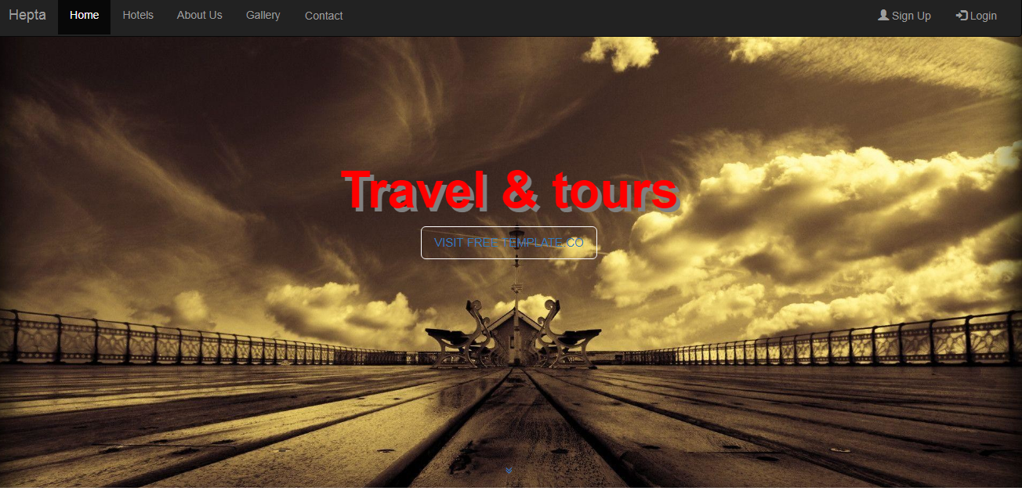

***Carousel:-***  A **carousel** is a set of rotating banners, or a slideshow, that displays on the homepage of your store. It allows you to display up to five slides consisting of **images** and text, which can be linked to specific products or pages. The **image** will change every few seconds.

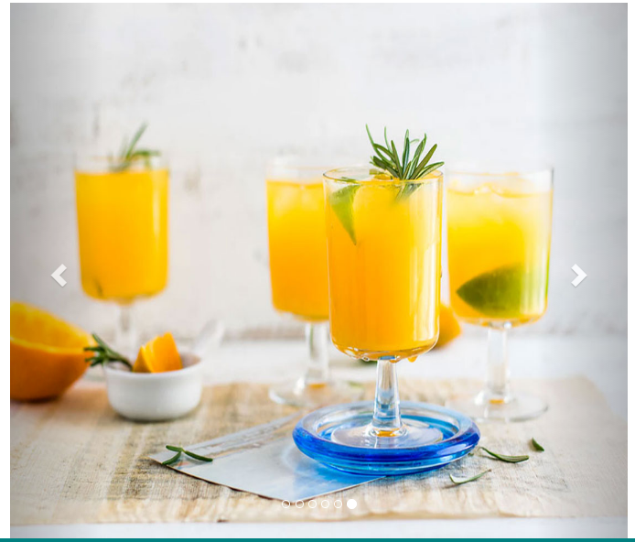

***Modal:-*** A modal is a dialog box/popup window that is displayed on top of the current page:In my project Modal used in contact Button.In this user can send a message or by visiting on the given Addess.

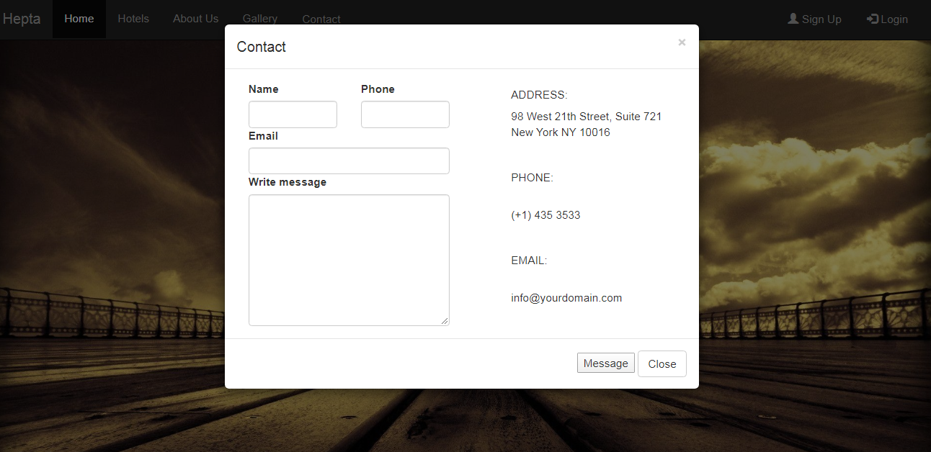

***SignUp Form:-*** In this form user can Register or signup in our website .

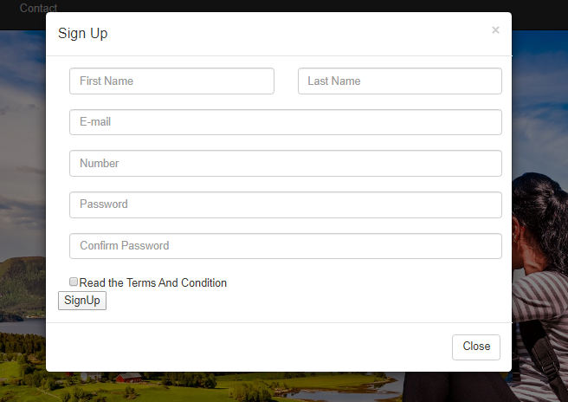

***Login form:-*** In this only registered user can login in website. No other can login in my website.

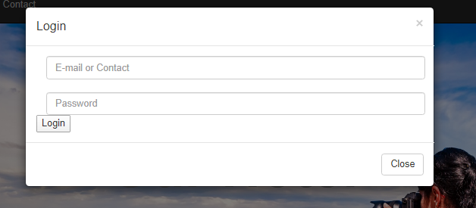

*Font Awesome:-* Font Awesome is a font and icon toolkit based on CSS **.**

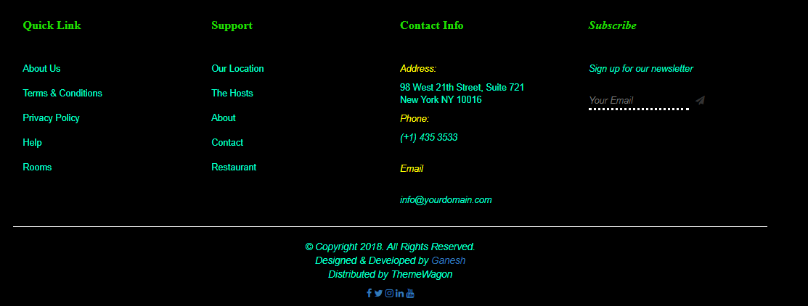

## MODIFICATION AND IMPROVEMENT OVER THE EXISTING IMPLEMENTATION

## After implementation of project:

* Students can register online no rush for registration in Placementdepartment.
* Respective eligible students can get informed by emailautomatically.
* List of eligible students can be made on single click.
* Report of students according to need of placement cell can be generated easily.
* Burden of Placement cell decreases.

## SCOPE

This project has a large scope as it has the following features which help in making it easy to use, understand and modify it:

* Automation of Placement Procedure
* No Need to do PaperWork.
* To save the environment by using paper freework.
* To increase the accuracy and efficiency of the placementprocedure.
* Management of Student Data.

This software package can be readily used by non-programming personal avoiding human handled chance of error. This project is used by two types of users

1. Students.

.

#### Main Points are:-

* Simplified Management of StudentProfiles.
* Job Posting.
* Selection Results.
* Real-time Information Publishing through system aler

## TOOLS AND TECHNOLOGY USED

#### Tool:

* ***XAMPP*** :-The use of XAMPP is to test the clients or your website before uploading it to the remote web server. This XAMPP server software gives you the suitable environment for testing MYSQL, **PHP**, Apache and Perl projects on the local computer.
* **MSSQL**: - Microsoft SQL Server is a relational database management system developed by Microsoft. As a database, it is a software product whose primary function is to store and retrieve data as requested by other software applications, be it those on the same computer or those running on another computer across a network (including the Internet). There are at least a dozen different editions of Microsoft SQL Server aimed at different audiences and for different workloads (ranging from small applications that store and retrieve data on the same computer, to millions of users and computers that access huge amounts of data from the Internet at the sametime).

#### Technology:

* **Bootstrap** is a framework to help you design websites faster and easier. It includes HTML and CSS based design templates for typography, forms, buttons, tables, navigation, modals, image carousels, etc. It also gives you support for JavaScript plugins.
* **SQL**: - SQL is a structured query language used for querying database.
* **HTML**: - It is used for giving eye catching look to the website. And also providing easy touse GUI.
* **CSS**: - CSS is cascading style sheet which is used to give designer look to HTML using the externalfile.
* **Java script**: - Java script is used for client side scripting which can help in using validation on the website and many more otherfunctions.
* ***PHP* :- PHP** stands for Hypertext Preprocessor (no, the acronym doesn't follow the name). It's an open source, server-side, scripting language used for the development of web applications. By scripting language, we mean a program that is script-based (lines of code) written for the automation of t